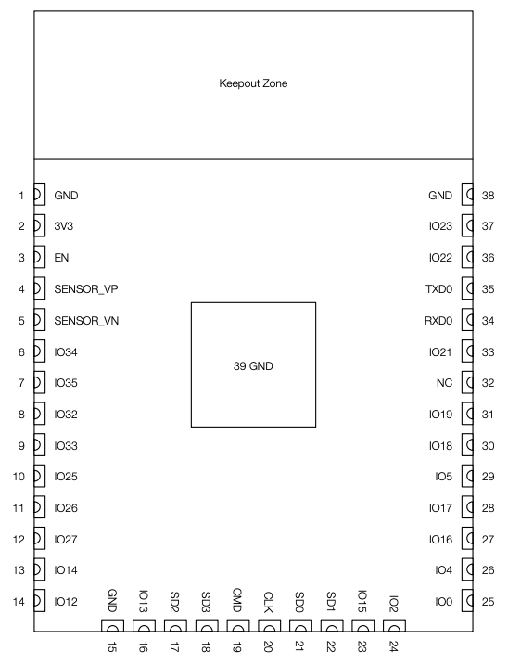

The ESP32 module pinout and descriptions are based on the image and datasheet provided. **Power and Ground Pins:**

* **Pin 1 (GND)**: Ground connection, used to complete circuits with other components.
* **Pin 2 (3V3)**: 3.3V power supply pin.
* **Pin 38 (GND)**: Another ground connection (same as pin 1).

### **Enable Pin:**

* **Pin 3 (EN)**: Module-enable signal, active high. This pin is used to enable or disable the ESP32.

### **Sensor Pins:**

* **Pin 4 (SENSOR_VP)**: This pin is connected to GPIO36 and is used for analog-to-digital conversion (ADC1_CH0) or as a Real-Time Clock (RTC) GPIO0.
* **Pin 5 (SENSOR_VN)**: This pin is connected to GPIO39 and is also used for analog-to-digital conversion (ADC1_CH3) or as RTC GPIO3.

### **General Purpose Input/Output (GPIO) Pins:**

* **Pin 6 (IO34)**: Connected to GPIO34, this pin is used for ADC1_CH6 (analog input) and RTC GPIO4.
* **Pin 7 (IO35)**: Connected to GPIO35, this pin is used for ADC1_CH7 (analog input) and RTC GPIO5.
* **Pin 8 (IO32)**: Connected to GPIO32, this pin can be used for ADC1_CH4 (analog input), RTC GPIO9, and is part of the Touch9 input.
* **Pin 9 (IO33)**: Connected to GPIO33, this pin is used for ADC1_CH5, RTC GPIO8, and part of the Touch8 input.
* **Pin 10 (IO25)**: Connected to GPIO25, this pin is used for DAC1 (digital-to-analog conversion) and RTC GPIO6.
* **Pin 11 (IO26)**: Connected to GPIO26, this pin is used for DAC2 and RTC GPIO7.
* **Pin 12 (IO27)**: Connected to GPIO27, this pin is used for analog input (ADC2_CH7), and can also be used as RTC GPIO17 or part of the Touch7 input.
* **Pin 13 (IO14)**: Connected to GPIO14, used for ADC2_CH6, RTC GPIO16, and is part of Touch6 input.
* **Pin 14 (IO12)**: Connected to GPIO12, used for ADC2_CH5, RTC GPIO15, and part of the Touch5 input.
* **Pin 16 (IO13)**: Connected to GPIO13, used for ADC2_CH4, RTC GPIO14, and part of Touch4 input.
* **Pin 25 (IO0)**: Connected to GPIO0, used as an input/output pin, also has a role in boot mode.
* **Pin 26 (IO4)**: Connected to GPIO4, used for ADC2_CH0 and part of Touch0 input.
* **Pin 27 (IO16)**: General-purpose input/output pin.
* **Pin 28 (IO17)**: General-purpose input/output pin.
* **Pin 29 (IO5)**: Connected to GPIO5, this pin is used for general-purpose input/output.
* **Pin 30 (IO18)**: General-purpose input/output pin.
* **Pin 31 (IO19)**: General-purpose input/output pin.
* **Pin 33 (IO21)**: General-purpose input/output pin.

### **Communication Pins:**

* **Pin 22 (SDI/SD1)**: This is the data input/output pin for SPI interfaces (serial peripheral interface).
* **Pin 20 (SCK/CLK)**: This is the clock signal pin for SPI interfaces.
* **Pin 23 (IO15)**: Can be used for SPI CS (chip select) and other general-purpose input/output functions.
* **Pin 34 (RXD0)**: Receive data (RX) pin for UART communication.
* **Pin 35 (TXD0)**: Transmit data (TX) pin for UART communication.

### **Reserved/No Connect:**

* **Pin 32 (NC)**: No connection, reserved for future use or not used in this configuration.

### **Summary:**

* The ESP32 has a mixture of general-purpose input/output (GPIO) pins, power pins (3.3V and GND), sensor input pins, and pins for communication interfaces (SPI, UART). Many of these pins support multiple functions, such as analog-to-digital conversion (ADC), touch input, or Real-Time Clock (RTC) integration. Each pin number corresponds to a specific GPIO with different features depending on the application.